Falcon Class Timetable - Term 1 2026-27
Turtterfly Class Timetable

 | 8.30 -8.55 | 8.55–9.20 | 9.20–9.50 | 9.50-10.50 | 10.50-11.05 | 11.10-12.10 | 12.10 – 1.10 | 1.10 – 1.30 | 1.30 – 2.15 |  | 2.15-3.00 | 3.00 – 3.10
Monday | Registration &  EMW/Handwriting practice/Nessy |  Worship | 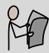 Guided reading | 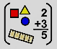 Maths |   Break-  time  Eat snack  Toilet  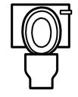 | 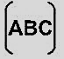  English | Lunch-time  Eat lunch    Toilet |  Quiet reading |   ICT |  |   Spanish | Story time
Tuesday | Registration &  EMW/Handwriting practice/Nessy | Worship | Guided reading | Maths |  | English |  | Quiet reading |   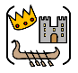  History/Geography |  |   Art/DT | Story time
Wednesday | Registration &  EMW/Handwriting practice/Nessy | Worship | Guided reading | Maths |  | English |  | Quiet reading | 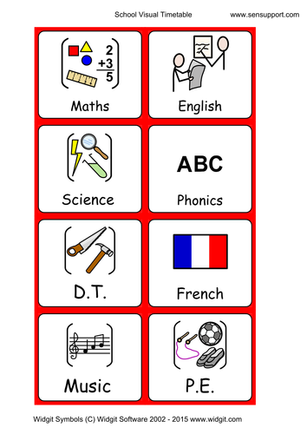  Science |  | Science | Story time
Thursday | Registration &  EMW/Handwriting practice/Nessy | Worship | Guided reading | Maths |  | English |  | Quiet reading | 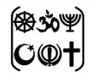  RE |  | 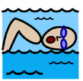  PE Swimming | Story time
Friday | Registration &  EMW/Handwriting practice/Nessy | Worship | Guided reading | Maths |  | English |  | Quiet reading | PE | 2 – 2:30  Music | 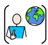  PSHE | Story time

